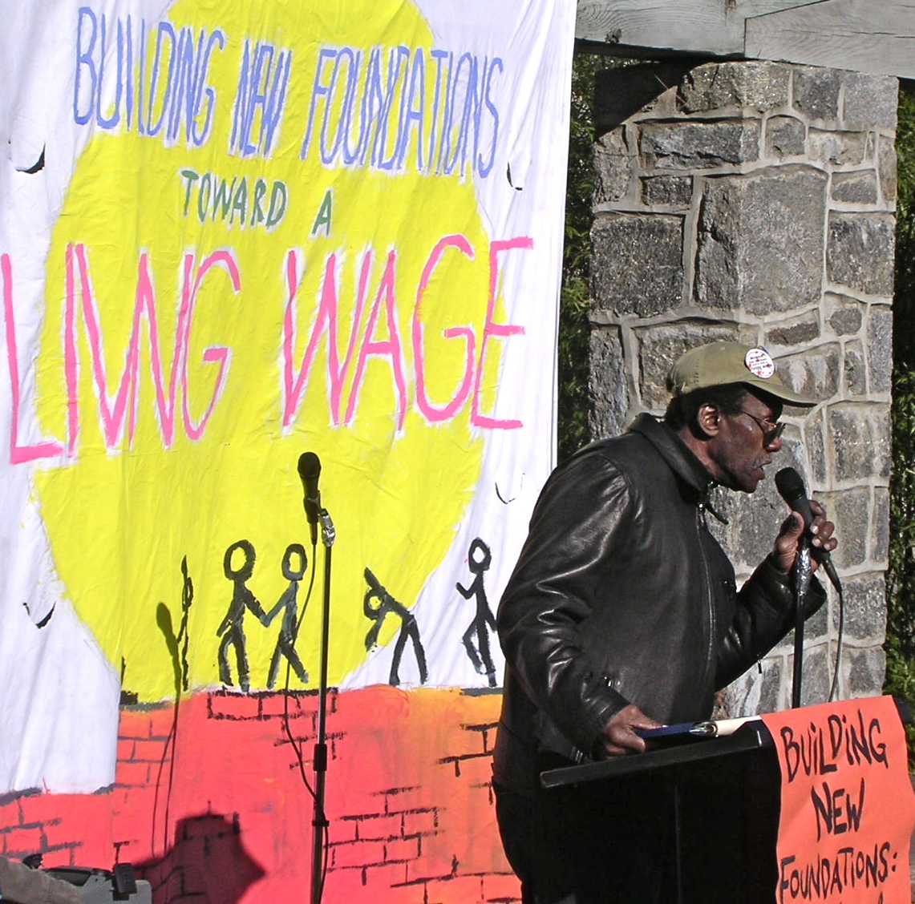

Unsung Hero of the Living Wage and Democracy Campaign
By Kae Kalwaic
Overlaps, Swarthmore College Student Publication, 2010

Hamza Abdula Wali is leaving Swarthmore as quietly as he came twelve years ago; and while his name may not be recognized now, his contributions to this community leave a legacy of solidarity and economic justice unparalleled in the history of Swarthmore College. Hamza was one of the leaders of the Living Wage and Democracy Campaign, which brought about the increase in wages of the lowest paid members of our community from a $5.35 starting wage to $10.38.
Diane Anderson introduced me to Hamza, who was a member of the Learning for Life program. I was immediately struck by his sincere and articulate expression of support for the living wage. I learned of his background when my son interviewed Hamza for an African American history course. The assignment required an autobiographical interview of a senior Black American, including both personal and political views. A proud man, Hamza refused to acknowledge the name given to his family through a slave master. He remembered when his relatives had to jump into ditches when white folks drove by in their cars. His grandparents were sharecroppers; his father was denied the opportunity to attend school. Although Hamza received a full scholarship to college, illness prevented him from continuing his academic studies. While working at Swarthmore, he returned to college and earned his associates degree.
Hamza brought compassion and dedication to the Campaign and was respected for his intelligence and his steadfastness. This was a hard fought campaign, ignited in 1999 and raged until our success in 2004 when the Board of Managers finally approved the base wage increase. Hamza was there from the beginning, leading meetings, preparing speeches, writing articles and communicating with his fellow workers in Environmental Services. He wrote letters to the Phoenix, words that still resonate with us now.
Sweepers say, beware of those who will dazzle you with speech and who pride themselves as experts and masters of what makes the economic system. Change comes, to be sure, when we shift corporate or governmental policies, elect more accountable leaders, or create effective institutional alternatives. But change comes when we stir the hearts of previously uninvolved citizens and help them to take their own moral stands. If enough people put their minds and bodies into this cause, a living wage will become a global phenomenon, and we all will win.
While many at the College remained reticent to speak out on the issue of the living wage, Hamza stepped forward. He spoke on panels and at discussions with alumni, and helped to organize meetings with students and the staff of Environmental Service. Hamza collected names for petitions. He did all of this without a cent of additional compensation and without recognition. There were no parties for his accomplishments, no honorary degrees, and yet he worked with staff members, students, and faculty and remained the lynchpin that held our principles together. After the Campaign, Hamza understood that in order to bring democracy to the workplace, workers needed to organize. Under difficult circumstances, he spearheaded a union drive with SEIU.
Often times those who have power have resources to reinforce and legitimize that power. But for Hamza and other members of the Campaign, power was not used over others but rather with others. He believed that community members must be treated as equals, not as pawns to be ignored, manipulated, or demeaned. For me personally, he always offered encouragement even in the most difficult moments of confronting power . . . “we will touch hearts to see the light regarding the Democratic way . . . we are on track to victory!”
While his name may fade from the collective memory, the legacy of Hamza’s accomplishment lives on in the quiet justice of a wage increase. On a Swarthmore webpage entitled “An Onward Spirit: A Brief History of Swarthmore College”, the living wage initiative is conspicuously absent from the timeline, although the new mascot received a mention. Howard Zinn reminds us that although activists sometimes remain obscure, the power of their own voice reinforces the power of protest and dissent. We cannot look for institutions to recognize marginalized voices; that acknowledgement will have to come from grassroots organizations within the institutions, and through publications such as Overlaps. I sincerely appreciate the opportunity to salute Hamza, an unsung hero who exemplifies ethical intelligence as living one’s life in a struggle for justice.

